My brother Jason has moved to college. He is learning a lot in college and spending time with new friends. I am happy that he is having fun at college.

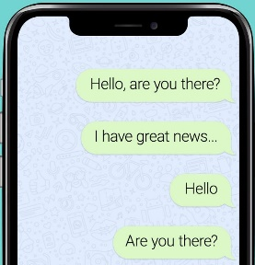But sometimes, I miss Jason a lot. I want to talk to Jason when I miss him. When I miss Jason, I want to call him or text him to talk to him.

But, Jason is busy and so he may not always answer or respond to my text right away. Sometimes this hurts my feelings, and makes me feel like Jason doesn’t care about me. Even though I feel sad or angry, I should not keep calling or texting Jason. I can trust that he will call or text me back when he has time.

Instead, when I feel angry and sad because Jason can’t answer the phone or text me, I can use the items in my coping skills kit to help me feel calm.

If I still can’t calm down, I can tell Mom or Dad that I am feeling sad because Jason can’t talk. Mom and Dad miss Jason too. If I talk to them about how I miss Jason, we can all help each other to feel better until the next time Jason can talk to us.